---

## Disaster Management System Documentation (Part 2)

**Security Measures:**

**Data Encryption** : We ensure end-to-end data encryption for data security during transmission and storage.

**Access Controls:** Role-based access control (RBAC) restricts system access to authorized users.

**Intrusion Detection**: Our system includes intrusion detection and prevention to identify and mitigate security threats.

**Data Protection**

**Backups:** Regular data backups are stored redundantly to prevent data loss.

**Disaster Recovery**: A disaster recovery plan is in place for rapid system restoration in case of failures.

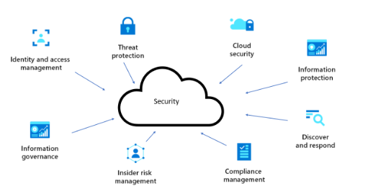

**User Training**

**User Guides:** Detailed user guides explain system functionality and features.

**Administrator Manuals:** Manuals for system administrators facilitate system management.

**Regular Updates**: Ongoing updates include security patches, bug fixes, and enhancements.

**System Monitoring:** Automated monitoring tools and manual checks ensure system reliability.

**Feedback Mechanism:** User feedback is collected and considered for future updates.

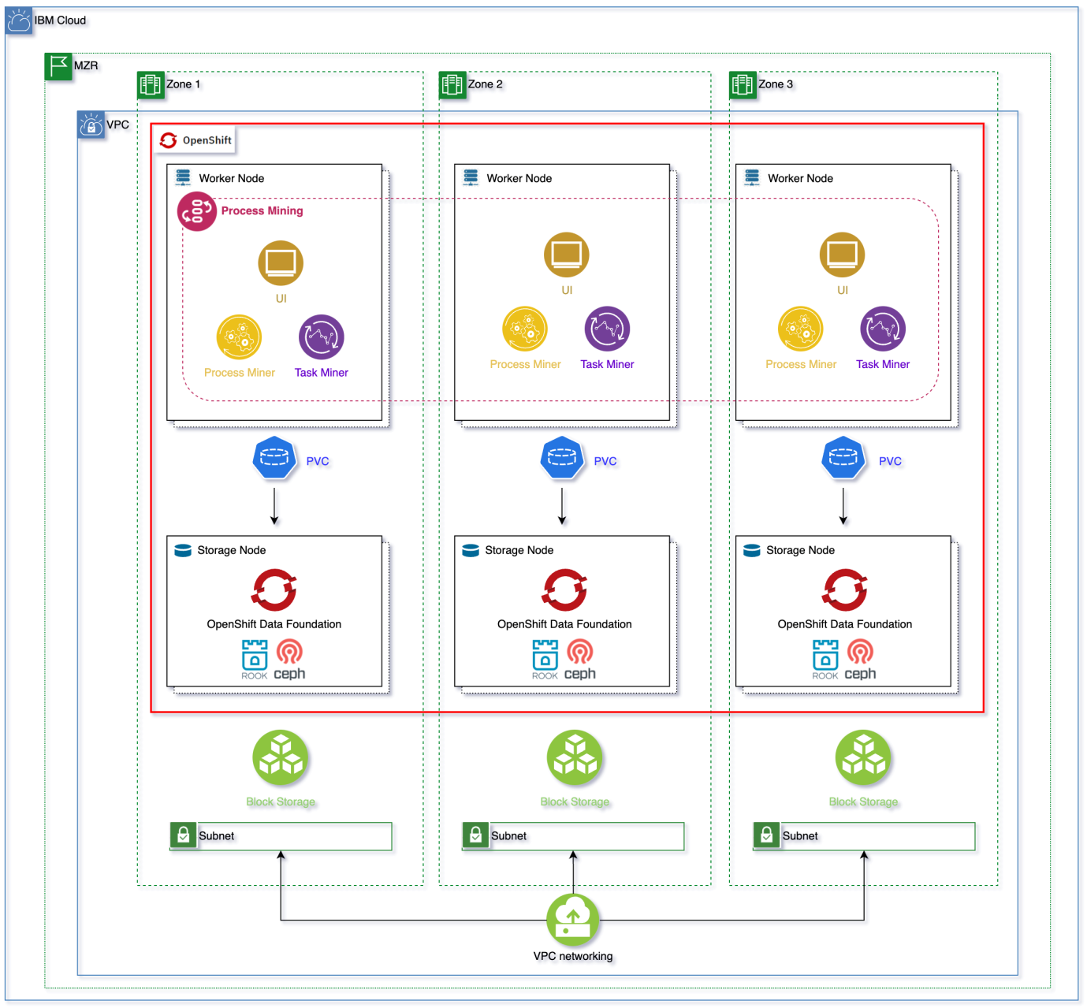

**Future Features**

**Machine Learning**: Integration of machine learning for disaster impact prediction.

**Enhanced Reporting:** Improved reporting capabilities for incident analysis and performance tracking.

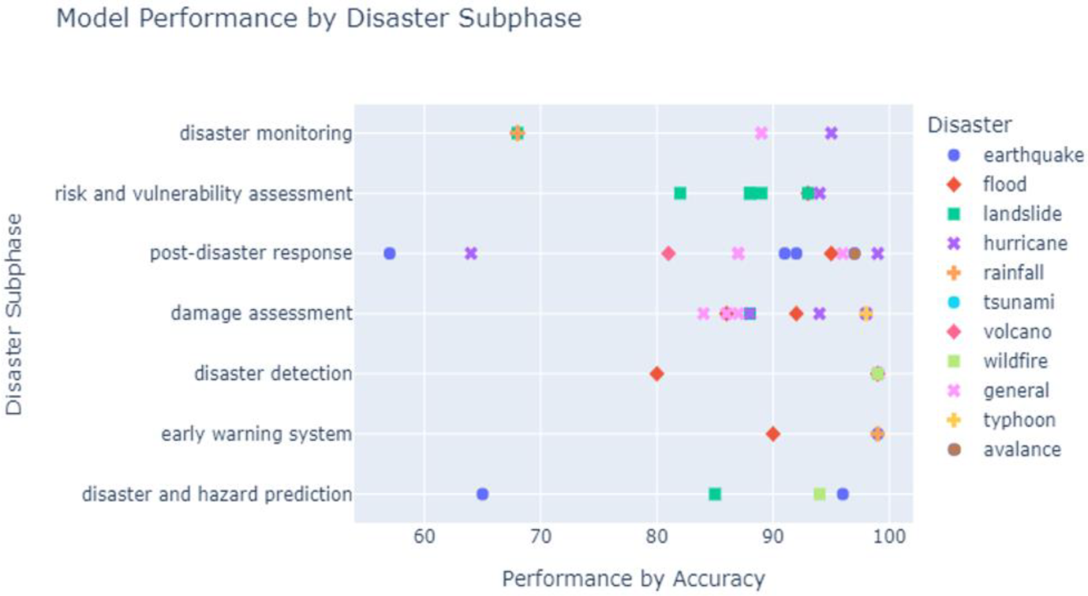

**CONCLUSION :**

In the course of developing our Disaster Management System, we have established a robust platform that leverages IBM Cloud Foundry and related technologies to enhance disaster preparedness and response. This project has allowed us to achieve several critical objectives. This is how the further model of our Disaster Recovery model will be developed. These additional features like security, user training and future features will be added. Our model will be under constant development and maintenance to add on future trending tech stacks and to enable the disaster recovery model with new user friendly options.We are also thinking to add on further ideas of using the Emergency Alert Technology used by the GOVERNMENT OF INDIA. We enable that technology to send the in formations to the user at times of emergency .Which we are looking forward to explore and add on.

As we move forward, we remain dedicated to ensuring the effectiveness and reliability of our Disaster Management System. We understand the critical role it plays in addressing the challenges posed by natural and man-made disasters, and we are committed to continuous improvement to better serve our communities. Our mission is to provide a powerful, responsive, and secure platform that empowers stakeholders to respond swiftly and effectively to disasters, ultimately saving lives and reducing the impact of catastrophic events.

